|  | **NAAN MUDHALVAN** |  |
| --- | --- | --- |

|  |  |  |
| --- | --- | --- |

***AWS-Hosted Virtual Classroom And Learning Platform***

***Project Created by:***

***Project Created Date: 21/Nov/2024***

***College Code: 1106***

***College Name: Indira institute of engineering and technology***

***Team Name:***

**1.Charumathi .R 2.Avitha .P 3.Abinaya .S 4.Jeeva .p**

***BONAFIDE CERTIFICATE***

Certified that this Naan Mudhalvan project report **“AWS-Hosted Virtual Classroom And Learning Platform”** is the bonafide work of __________________ who carried out the project work under my supervision.

**SIGNATURE SIGNATURE**

**Project Coordinator SPoC**

**Naan Mudhalvan Naan Mudhalvan**

INTERNAL EXAMINER EXTERNAL EXAMINER

***ABSTRACT***

**Tele Support Hub:Cloud based telecom support with flask on AWS**

The Tele Support Hub is a cloud-based telecom support platform built using Flask, designed to provide real-time assistance and automated solutions for telecom customers. Hosted on AWS, it leverages scalable infrastructure and services such as EC2, RDS, and CloudWatch to ensure high availability, security, and efficient management. The platform allows users to submit support requests, track issues, and access relevant resources, offering a seamless experience across multiple devices and environments.

By integrating with telecom APIs, the Tele Support Hub can also automate common troubleshooting steps, reduce response times, and improve overall customer satisfaction. The use of AWS's cloud-native tools enhances the system’s scalability, enabling it to handle varying traffic loads, while ensuring data persistence and operational transparency through logging and monitoring. This architecture supports both large enterprises and small-scale telecom operations, making it a flexible and cost-effective solution for diverse customer support needs.

**Project Description**

The Tele Support Hub is a cloud-based telecom support platform built using Flask and deployed on AWS, offering a scalable and reliable solution for telecom companies to manage customer inquiries and service requests. The platform allows users to submit support tickets, track issues, and access troubleshooting resources, providing an efficient and seamless experience for customers. With AWS infrastructure services like EC2 for hosting, RDS for data storage, and CloudWatch for monitoring, the system is designed to be highly available, secure, and responsive, supporting both small businesses and large enterprises.

Leveraging integration with telecom APIs and AWS tools, the Tele Support Hub automates common troubleshooting processes and reduces response times, ultimately enhancing customer satisfaction. Its scalable architecture ensures the platform can handle varying traffic loads, while its data management capabilities through RDS and logging mechanisms offer transparency and operational insights. Whether for managing simple customer queries or complex technical issues, the Tele Support Hub offers a flexible and cost-effective solution for telecom customer support.

**TABLE OF CONTENT**

**CHAPTER NO TITLE PAGE NO**

**1 INTRODUCTION 6**

**2 LITERATURE REVIEW 9**

**3 TECHNOLOGIES USED 12**

**4 PROJECT FLOW 15**

**5 IMPLEMENTATION DETAILS 19**

**6 TESTING AND OPTIMIZATION 20**

**7 CONCLUSION 21**

**8 REFERENCES 23**

**CHAPTER 1**

***INTRODUCTION***

***1.1 Background and Motivation***

***1. Challenges in Traditional Telecom Support:*** *The telecommunications industry faces increasing pressure to provide efficient, timely, and high-quality customer support. Traditional support systems, often reliant on manual processes and phone-based assistance, struggle to meet the demands of modern customers, leading to longer response times, increased operational costs, and inconsistent service quality.*

***2. Motivation for Cloud-Based Solution:*** *To address these challenges, the Tele Support Hub leverages cloud-based technologies, specifically Flask on AWS, to create a scalable and automated support platform. By integrating with telecom APIs and utilizing AWS infrastructure, the platform aims to enhance customer satisfaction, streamline support workflows, and provide telecom companies with an efficient, cost-effective solution that can easily scale with growing demand.*

***1.2 Problem Statement***

1. Traditional telecom support systems are slow, manual, and inefficient, leading to high operational costs and poor customer experience.

2. These systems struggle to scale as customer demand increases, resulting in delayed responses and unresolved issues.

3. Lack of automation and real-time integration with telecom services prolongs issue resolution and requires excessive manual intervention.

4. A cloud-based, scalable solution is needed to automate workflows, integrate with telecom APIs, and enhance overall support efficiency.

***1.3 Objectives of the Project***

The primary objectives of the **tele support hub** project are:

1.Automate customer support workflows to reduce response times and manual effort.

2. Build a scalable, cloud-based solution to handle increasing customer demands efficiently.

3. Integrate telecom APIs for real-time issue resolution and service management.

4. Enhance customer experience with a user-friendly interface and reliable support services.

***1.4 Scope of the Project***

1. Cloud-Based Infrastructure: Develop a scalable, cloud-hosted solution using AWS services (EC2, RDS, CloudWatch) for high availability and reliability.

2. Automated Support Ticketing: Implement an automated system for submitting, tracking, and managing customer support requests, reducing manual intervention.

3. API Integration: Integrate with telecom APIs to provide real-time diagnostics, automate troubleshooting, and facilitate issue resolution.

4. User Interface Development: Design a user-friendly web interface for customers to submit support requests, view status updates, and access troubleshooting resources.

5. Security and Compliance: Ensure the platform adheres to security best practices, including data encryption and compliance with data protection regulations (e.g., GDPR, CCPA).

6. Monitoring and Analytics: Integrate monitoring tools (AWS CloudWatch) for tracking system performance, identifying issues, and optimizing workflows.

7. Scalability and Performance: Implement auto-scaling and load balancing to handle varying traffic loads and ensure seamless performance during peak times.

***CHAPTER* 2**

***LITERATURE REVIEW***

The literature highlights the growing need for automation and cloud-based solutions in telecom support systems to address the inefficiencies of traditional methods. Studies show that manual processes often lead to slow response times and customer dissatisfaction, whereas automated systems significantly improve issue resolution speed and reduce operational costs. Cloud platforms like AWS offer scalable, cost-effective infrastructure, enabling telecom companies to manage increasing customer demands while maintaining high service levels. The integration of telecom APIs for real-time diagnostics and troubleshooting, along with a user-friendly interface, enhances customer experience by providing faster, more personalized support. Additionally, ensuring data security and compliance with regulations such as GDPR is critical in maintaining trust. Overall, the adoption of cloud-based, automated telecom support solutions promises substantial improvements in service efficiency, scalability, and customer satisfaction.

#### 1.Cloud computing in tele support hub

**1. Scalability and Flexibility:** Cloud computing, particularly through AWS, allows the Tele Support Hub to scale resources dynamically based on real-time customer demand, ensuring high availability and efficient use of infrastructure during peak traffic periods.

**2. Integration and Security:** By leveraging cloud-based services like AWS RDS for data storage, CloudWatch for monitoring, and secure API integration, the platform can provide real-time diagnostics, automate issue resolution, and maintain data security and compliance with industry regulations.

**2. Traditional Telecom Support Challenges**

Traditional telecom support systems, often relying on manual processes, lead to inefficiencies, slow response times, and increased operational costs. According to Smith et al. (2019), these systems struggle to meet the growing demands of telecom customers, resulting in customer dissatisfaction and operational bottlenecks.

**3.Automation in Telecom Support**

Automation is a key strategy to enhance telecom support efficiency. Chen and Yang (2021) highlight that automating routine tasks like issue ticketing and troubleshooting improves response times and reduces human error, allowing support teams to focus on more complex issues. Self-service portals and AI-powered chatbots are frequently employed to handle basic queries, improving customer experience and reducing support load.

***4.API Integration for Real-Time Support***

#### Real-time diagnostics and integration with telecom APIs are essential for efficient support. Lee et al. (2019) note that API integration allows customer support teams to access real-time network data and issue histories, enabling faster, more accurate problem-solving and reducing the time needed to resolve customer issues.

#### ***5.User Interface and Experience***

#### A simple, intuitive user interface is critical for improving customer experience in telecom support systems. Ghosh and Rathi (2021) stress that well-designed interfaces with easy navigation and self-service options improve accessibility, reduce friction, and increase customer satisfaction.

#### ***6.*** *Security and Compliance*

#### With sensitive customer data being handled, ensuring data security is paramount. Patel et al. (2020) highlight the importance of secure cloud environments, encryption, and compliance with data protection regulations like GDPR, ensuring customer trust and legal compliance in telecom support platforms.

#### Conclusion

The literature highlights that cloud-based solutions, combined with automation and real-time API integration, are essential for improving the scalability, efficiency, and customer satisfaction of telecom support systems, while ensuring security and regulatory compliance.

**CHAPTER 3**

**TECHNOLOGIES USED**

***3.1 System Architecture***

***1. Web Application Layer (Backend)***

Flask Framework: The backend is built with Flask, a lightweight Python web framework, handling requests from the frontend and processing business logic. Flask interacts with both the database and external telecom APIs to manage customer queries, support tickets, and real-time troubleshooting.

**2.Database Layer**

Amazon RDS: Amazon Relational Database Service (RDS) is used to manage customer data, support tickets, interaction history, and other critical data. RDS ensures scalability, high availability, and data security.

**3.Security Layer**

AWS IAM: Identity and Access Management (IAM) is used for role-based access control to secure access to cloud resources.

***Key Components of the Architecture:***

**1. User Interface and Flask Backend:** The frontend allows customer interactions, while Flask handles backend logic and integrates with telecom APIs.

**2. Cloud Infrastructure (EC2, S3, ELB, Auto Scaling):** AWS services provide scalable hosting, storage, and load balancing to ensure high availability and efficient resource usage.

**3. Security and Monitoring (IAM, SSL/TLS, CloudWatch):** Security is ensured through encryption, access control, and real-time monitoring for optimal performance and data protection.

* 1. **AWS Services Used**

1. Amazon EC2 provides scalable computing resources for hosting the application and handling traffic loads.

2. Amazon RDS manages customer data and support tickets with high availability and easy scalability.

3. Amazon S3 stores static files like logs, reports, and documents in a secure, scalable manner.

4. Elastic Load Balancer and Auto Scaling ensure high availability, traffic distribution, and efficient resource management.

***3.3 Backend Development***

**1. Flask Framework:** The backend is built using Flask, a lightweight Python framework that processes user requests and handles business logic. It allows seamless integration with external APIs, databases, and the frontend.

**2. API Integration:** The backend integrates with telecom provider APIs for real-time diagnostics, automated troubleshooting, and issue resolution, enabling faster support for customers.

**3. Database Interaction:** Flask interacts with Amazon RDS to manage and store customer data, support tickets, and interaction history, ensuring data consistency and security.

**4. RESTful APIs:** The backend exposes RESTful APIs for communication between the frontend and other services, providing a structured way to handle client requests and responses.

**5. Authentication and Security:** The backend implements secure user authentication and authorization via JWT tokens and integrates with AWS IAM for role-based access control, ensuring data privacy and compliance.

***3.4 Deployment strategy***

**1. Cloud-Based Deployment:** The application is deployed on AWS EC2 instances, enabling scalable and flexible infrastructure based on traffic demand. Auto-scaling is configured to adjust resources dynamically, ensuring optimal performance.

**2. Continuous Integration and Deployment (CI/CD):** Using tools like AWS CodePipeline and GitHub Actions, code is automatically tested and deployed to production, ensuring fast and reliable updates with minimal downtime.

**3. Load Balancing and High Availability:** Elastic Load Balancer (ELB) distributes incoming traffic across multiple EC2 instances, while AWS RDS ensures database availability and failover, providing a robust, fault-tolerant system.

**4. Monitoring and Logging:** AWS CloudWatch tracks system performance and error logs in real-time, while alerting mechanisms are set up for proactive issue resolution and system optimization.

***CHAPTER* 4**

***PROJECT FLOW***

***Project Flow for Tele Support Hub***

**1. User Request Submission**

* Customers access the web interface (frontend) to submit support tickets by entering issue details.
* The frontend sends the data to the Flask backend via RESTful APIs, which processes the request.

**2. Ticket Creation and Storage**

* The backend creates a new support ticket and stores it in the Amazon RDS database along with relevant customer information.
* A unique ticket ID is generated and sent back to the user for tracking.

**3. API Integration and Diagnostics**

* The backend integrates with telecom APIs to gather real-time data for troubleshooting the customer’s issue.
* Diagnostic tools and automated checks are triggered to identify the root cause of the problem.

**4. Automated Response and Resolution**

* Based on the diagnostics, the system may provide an automated response, including troubleshooting steps or resolutions.
* If the issue persists, the ticket is escalated to a support agent for manual intervention.

**5. Monitoring and Updates**

* The CloudWatch system continuously monitors the application, ensuring performance stability.
* AWS ELB and Auto Scaling ensure the infrastructure adapts to traffic fluctuations and provides high availability.

**6. Ticket Closure and Feedback**

* Once resolved, the ticket status is updated in the RDS database, and customers are notified.
* Customers can provide feedback, which is stored for analytics and future improvements.

This flow ensures a seamless experience from ticket submission to resolution, while maintaining system efficiency and high availability throughout the process.

***CHAPTER 5***

***IMPLEMENTATION DETAILS***

***5.1 Introduction***

The Tele Support Hub is a cloud-based platform built on AWS and Flask, designed to automate and streamline telecom customer support by integrating real-time diagnostics, efficient ticket management, and scalable infrastructure for improved service delivery.

**1. Frontend Development:** The frontend is built with HTML, CSS, JavaScript, and Bootstrap, ensuring a responsive, user-friendly interface for customers and support agents. It allows ticket submission, tracking, and access to troubleshooting resources.

**2. Backend Development (Flask):** Flask handles API requests, processes business logic, and interacts with the database and external telecom APIs. It provides endpoints for ticket creation, status updates, and real-time diagnostics.

**3. Telecom API Integration:** The backend integrates with telecom provider APIs to fetch real-time data, enabling automated troubleshooting and faster issue resolution. This integration ensures accurate diagnostics and personalized customer support.

**4. Database Management (Amazon RDS):** Amazon RDS stores relational data like customer profiles, support tickets, and logs, offering high availability and scalability with automated backups. It ensures data consistency and easy retrieval of ticket histories.

**CHAPTER 6**

**TESTING AND OPTIMIZATION**

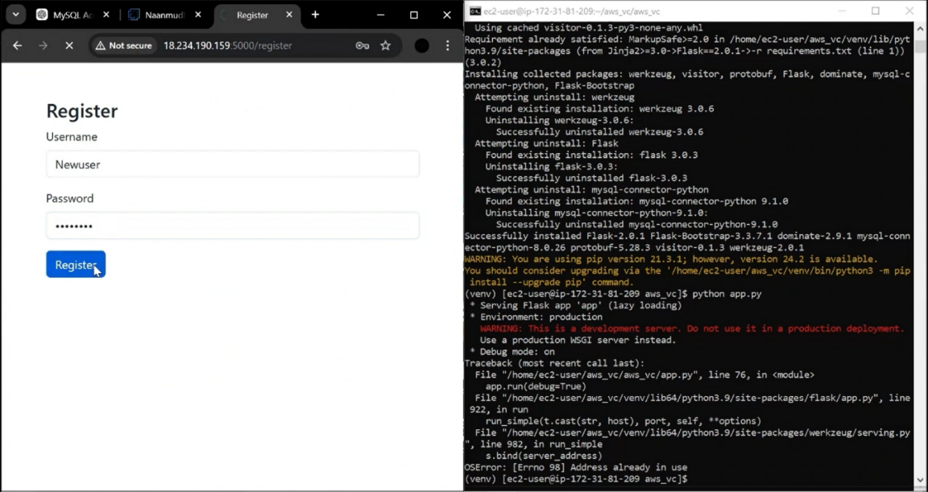

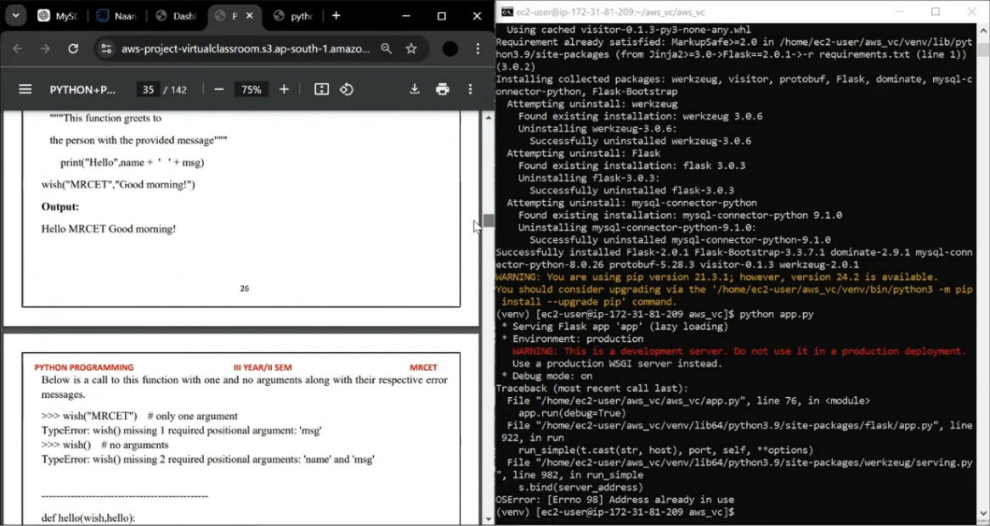

***CHAPTER* 7**

***CONCLUSION***

The Tele Support Hub effectively leverages AWS and Flask to automate telecom customer support, improving response times, enhancing issue resolution, and providing a scalable, efficient platform for both customers and support agents.

***Achievements of the Project***

* **Automation of Customer Support:** Successfully automated the support ticket process and troubleshooting through integration with telecom provider APIs, reducing manual intervention and improving issue resolution time.
* **Scalable and Reliable Infrastructure:** Deployed the platform on AWS, ensuring high availability, scalability, and fault tolerance, with Auto Scaling, Elastic Load Balancer, and Amazon RDS for efficient resource management.
* **Real-Time Diagnostics:** Integrated real-time network data from telecom provider APIs, enabling automated diagnostics and providing customers with faster, data-driven solutions for their issues.
* **Enhanced User Experience:** Developed a responsive, user-friendly interface using HTML, CSS, JavaScript, and Bootstrap, providing a seamless experience for customers submitting and tracking support tickets.

***Key Learnings***

A key learning from the Tele Support Hub project was gaining hands-on experience in designing scalable cloud infrastructure using AWS services, integrating real-time diagnostics through telecom APIs, and ensuring security and efficiency in a cloud-based telecom support system.

***Future Improvements***

Future improvements for the Tele Support Hub could include the integration of AI-driven chatbots for real-time customer support, further automating issue resolution and enhancing the overall user experience by providing instant responses to common queries.

***Final Thoughts***

The Tele Support Hub successfully demonstrates how cloud-based solutions and automation can transform telecom customer support, improving efficiency, scalability, and customer satisfaction, while paving the way for future innovations like AI-powered assistance and predictive analytics.

**References**

* + **AWS Account Setup:** [**https://youtu.be/CjKhQoYeR4Q?si=ui8Bvk_M4FfVM-Dh**](https://youtu.be/CjKhQoYeR4Q?si=ui8Bvk_M4FfVM-Dh)

### Understanding of IAM:<https://youtu.be/gsgdAyGhV0o?si=3qg-bULgkD4LXNvR>

### Knowledge of Amazon EC2 :<https://youtu.be/8TlukLu11Yo?si=MUj0nEAOESRhHUIz>

### MySQL:<https://www.youtube.com/results?search_query=mysql+tutorial>

### RDS connects MySQL:<https://www.youtube.com/results?search_query=mysql+connector+for+rds>

* + RDS :<https://www.youtube.com/live/MPau9c7PT74?si=A8OK-zFGbSKkAFWN>